Chart 1:

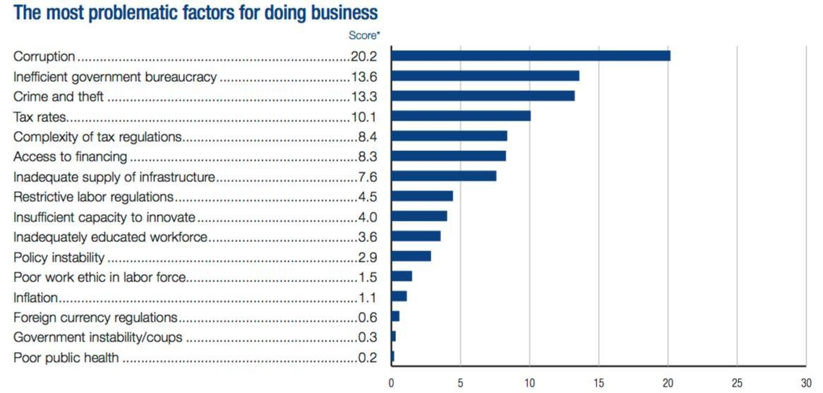
Source: The World Economic Forum (WEF) (2016) This is how Mexico is fighting corruption, in Global Competitiveness Report 2016, New York, USA.

Chart 2:

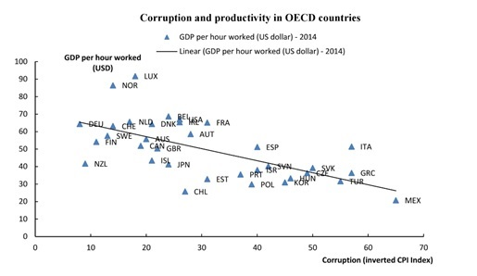
Source: The Organization for Economic Co-operation and Development (OECD), (2016) Investing in integrity for productivity, Paris, France, OECD publishing.

Chart 3:
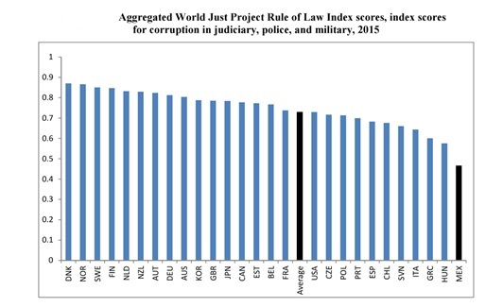

Source: Organization for Economic Co-operation and Development (OECD) (2017) Integrity Review of Mexico. Taking a strongest stance against corruption, Paris, France, OECD publishing.

